Alpharetta Arts Streetfest 2022 Artist/Sponsor/Vendor Instructions
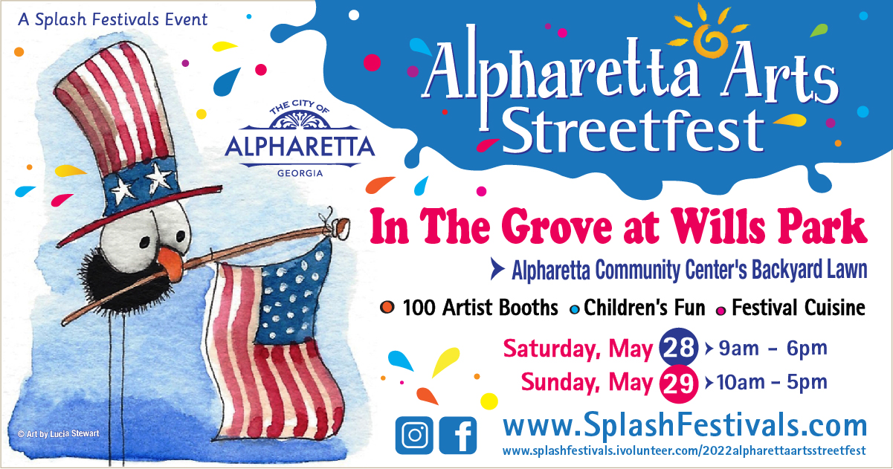

WE LOVE ALL OF YOU AND ARE SO EXCITED THAT YOU ARE JOINING US!

Festival Hours of Operation
Saturday, May 28, 9am to 6pm
Sunday, May 29, 10am to 5pm
Link to Festival Overview Map: https://www.eventeny.com/events/map/?id=1623&mid=1414

Alpharetta Arts Streetfest is returning to the Grove at Wills park (GPS 175 Roswell St., Alpharetta, GA 30009). This park setting is perfect for an art festival. We have shade, sun and convenient parking for everyone - not to mention a close-by dog park. Please see below for details regarding setup and other important stuff.

Check-in
- Check-in is on Friday May 27. Pay attention, ya’ll! Your load-in time is based on your booth location and is noted on the booth assignment list.

Vehicles weighing 7500 lbs or less (loaded) will be able to pull up to the booth to unload.

Vehicles weighing more than 7500 lbs may not drive on the pavement and will be required to dolly in.

Your assignment has been made according to what type of vehicle you indicated you would be bringing on your application.

Once all exhibitors are unloaded, they will need to move their vehicles to the exhibitor parking area at Amana Academy, 285 S Main St, which is a short walk from the Park. Follow the Exit signs to exit the unloading area. Be sure to park in the designated parking area for Exhibitors at Amana. This will also be your parking area for the weekend. See below more parking details.

Late Check-in will be Saturday morning between 7:00 and 7:30am. The Festival opens at 9am and all vehicles must be removed by 8:30am.

- Upon arrival, you will receive a parking pass for your windshield. Staff will then direct you to your booth location to unload. There will not be any unloading volunteers (that we are famous for and you have grown to love), as it is Friday, and a lot of folks will still be at work. Be prepared to dolly your items if you are pulling a heavy trailer, driving an RV, or have a large truck. If you are not sure of the weight of your vehicle, please look it up on the internet to make sure you will be able to drive to your spot.
- Your check in packet will contain your booth placard which should be attached to the top left (facing) side of your canopy.
- A sales tax form will be provided. Alpharetta is 9.25%.

Setup
NO STAKING IS ALLOWED. Please bring weights equal to 40lbs per tent leg. on each side.
Parking

Exhibitor Parking
Exhibitor parking will be located at Amana Academy, 285 S Main St. and will be WITHIN THE DESIGNATED AREA ADJACENT TO REGIONS BANK. Look for the signs to Exhibitor Parking. There will be ample room for trailers and RVs beginning Friday evening. DO NOT PARK IN UNDESIGNATED AREAS, AS THIS IS A SCHOOL AND TEACHERS WILL UTILIZE THE OTHER AREAS. It will be a very short walk to the Festival area. DO NOT PARK IN THE ALPHARETTA COMMUNITY CENTER WHERE YOU LOADED IN ON FRIDAY.

Sunday parking will be at Amana Academy. You will be given written load-out instructions Sunday morning. Do not attempt to park at the Alpharetta Community Center Sunday morning. No points will be gained with Splash or the City of Alpharetta! We’ll allow trailers to come in Sunday afternoon in a designated area so you’ll be able to dolly and load efficiently. You’ll be able to move your trailers in once attendees have started to thin later in the afternoon.

General Information

Exhibitor Rules of Etiquette
We love all of our artists, sponsors and vendors. You are our guests, and we are truly grateful that you are part of the festivities! To be fair to everyone, however, please refrain from distributing literature or other advertising materials from beyond your booth space. It is important that you promote yourself and your amazing products, but you must keep your sales pitch from disturbing or distracting customers away from your neighbor's spot. We appreciate your cooperation!

Smoking Policy
We ask that if you must smoke, please take a break and do so away from the other Exhibitors. We appreciate your cooperation in this matter.

Services

Security
Private security will provide overnight security of the Festival premises on Friday and Saturday evenings. All exhibitors are required to secure their tents to deter theft.

Headquarters/Lost & Found/ First Aid
Headquarters, Lost and Found and First Aid are located in the pavilion in the center of the field.

Restrooms
Restrooms are located inside of and in front of the Community Center.

Ice
No ice will be available on site. You’ll need to bring your own.

Power
Unless previously approved, we do not allow separate generators to be utilized. If you did not order electricity, please let us know ASAP, as it will only be available in limited locations. If you ordered electricity, please bring 100ft. extension cords to connect to the power source.

Food Vendors: There are no containers for grease or gray water disposal. You must bring your own. Water WILL NOT BE AVAILABLE

Important Notes
- Only those food items stated in your contract may be served. A copy will be on site in the event of any discrepancies. There may be a limited amount of duplication in food items. If you have concerns, please contact Cindy Flynn at 678-427-6450. Vendors who attempt to sell unauthorized food items will be required to stop selling those items.
- All prices must be clearly posted.
- Please refrain from playing music from your set up.
- For any other specifics, please refer to your contract.

IMPORTANT DETAILS

Inclement Weather/Emergencies
Although Alpharetta Arts Streetfest will happen rain or shine, if weather or another emergency happens during the weekend that would be considered life threatening or dangerous, we’ll notify you through our text messaging system. To be able to receive these messages you must first opt in by texting to 84483 the message ALPSTREET. Although the service is free, text-messaging rates may apply depending on your data plan. After the event, your information will be purged from the system.

Refunds/Cancellations
All fees are non-refundable. No refund will be issued due to inclement weather. No refunds are issued for cancellations. If you cannot attend Alpharetta Arts Streetfest, please let us know by calling 470-342-5797 or 678-427-6450. This event will happen rain or shine.

Liability
Splash Festivals, Inc. and the City of Alpharetta will not assume liability for any act of God, natural disaster, exposure to adverse weather conditions, damages or injuries, or any cause above and beyond the control of Alpharetta Arts Streetfest. We appreciate everyone's cooperation! Neither Splash Festivals, Inc., the City of Alpharetta nor its agents or representatives will be responsible for any injury, damage or loss that may occur to the artist, the artist's agents or representatives or his or her property, regardless of the cause. Artists should obtain, at their own expense, any insurance they deem necessary.

Questions
If you have questions prior to Alpharetta Arts Streetfest, please contact:
Frances Schube 770-452-1727 (H) 470-342-5797 (C) rdemetrius72@aol.com
Cindy Flynn 678-427-6450 (C) splashfestivals@gmail.com

Sunday, May 30

Restocking begins at 8:30am. Please arrive at the location where you checked in Friday morning. Show your parking pass and a volunteer will allow you through to unload. Your vehicle must be removed from the unloading area by 9:30am. If you are not restocking, please plan to arrive at your booth no later than 9:30AM. Many attendees arrive before 10AM so you are encouraged to arrive earlier to open.

Load-out
Please keep your booth open until 5:00PM on Sunday. At close of Alpharetta Arts Streetfest, you must break down your booth and tent prior to moving your car from the parking area to the loading area. A staff member will issue you a Loading Ticket once you are packed. You’ll receive more specific instructions Sunday morning. DO NOT PARK IN THE COMMUNITY CENTER PARKING LOT SUNDAY morning because we will have a designated load out route and your vehicle will obstruct the process.

For safety purposes, no vehicles will be allowed to re-enter the paved pathway until 5:15PM or until the crowds have thinned sufficiently. All booths must be removed from the park by 9:00PM Sunday. Due to changing weather conditions, these instructions may change. Be sure to opt into the emergency text messaging system as instructed above to receive the latest updates.

